Total Videos Watched
https://www.linkedin.com/learning/fundamentals-of-business-process-mapping/the-benefits-of-process-mapping (2 Hours)
https://www.youtube.com/watch?v=6Juh83sxKkQ (10 Minutes)
https://www.youtube.com/watch?v=F8nmfMsLaSI (5 Minutes)
https://www.youtube.com/watch?v=4emxjxonNRI (13 Minutes)
https://www.youtube.com/watch?v=xsg9BDiwiJE (7 Minutes)
https://www.youtube.com/watch?v=hktyW5Lp0Vo (15 Minutes)
https://www.youtube.com/watch?v=KN-inGJG540 (8 Minutes)
https://www.youtube.com/watch?v=qtTWBs49BCA (5 Minutes)
https://www.youtube.com/watch?v=iaX11vYFhZ4 (5 Minutes)
https://www.youtube.com/watch?v=BYPsOmM2rLU (9 Minutes)

Findings

BPMN (Business Process Model and Notation)
A standardised graphical notation for modelling business processes end to end. It uses a defined symbol set — events (circles), activities (rounded rectangles), gateways (diamonds) and sequence flows — so the meaning is unambiguous across teams. Pools and lanes show which organisation or role owns each step. Because it is a formal standard (ISO 19510), models can be handed to developers or executed in workflow engines. Best used when a process needs precise documentation for automation or compliance rather than a quick sketch.
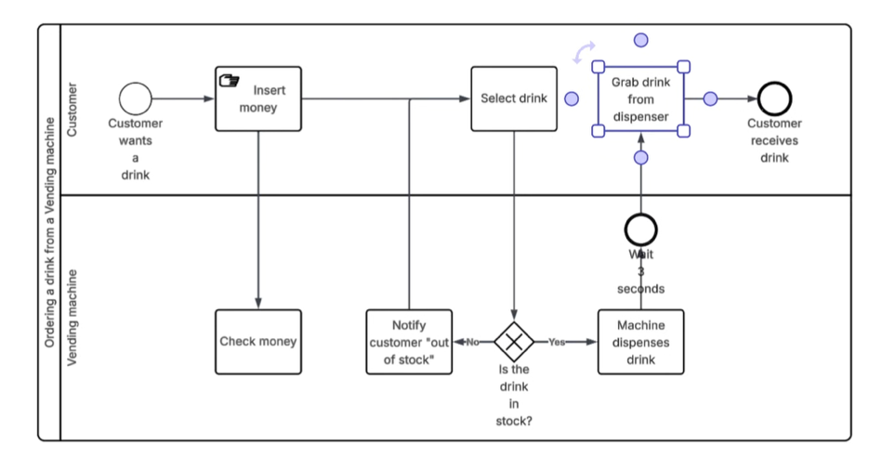

Use Case Diagram
A UML diagram showing what a system does from the user's point of view, not how it does it. Actors (stick figures) sit outside the system boundary; use cases (ovals) sit inside representing goals the actors want to achieve. Relationships include association, include (mandatory sub-behaviour), extend (optional behaviour) and actor generalisation. It gives stakeholders a one-page picture of scope — anything outside the boundary box is out of scope. Typically drawn early in requirements gathering to agree functional coverage before detailed specs.
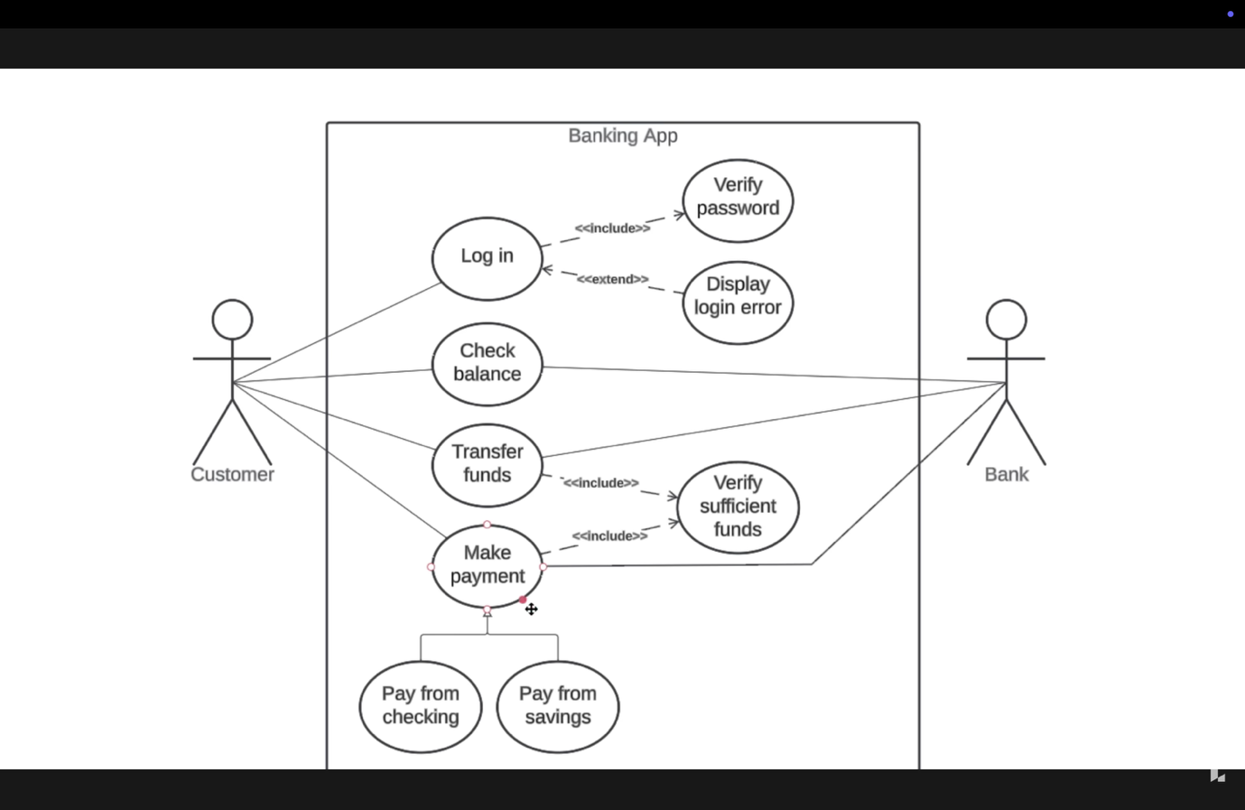

Entity-Relationship (ER) Diagram
Models the data a system stores: the things it cares about and how they relate. Entities become tables, attributes become columns, and relationships carry cardinality (one-to-one, one-to-many, many-to-many). Crow's foot notation is the common style for showing optionality and multiplicity on each end of a relationship. It is the bridge between business vocabulary and physical database design, usually refined through conceptual, logical and physical levels. Use it to spot missing data, redundancy, and normalisation problems before build.
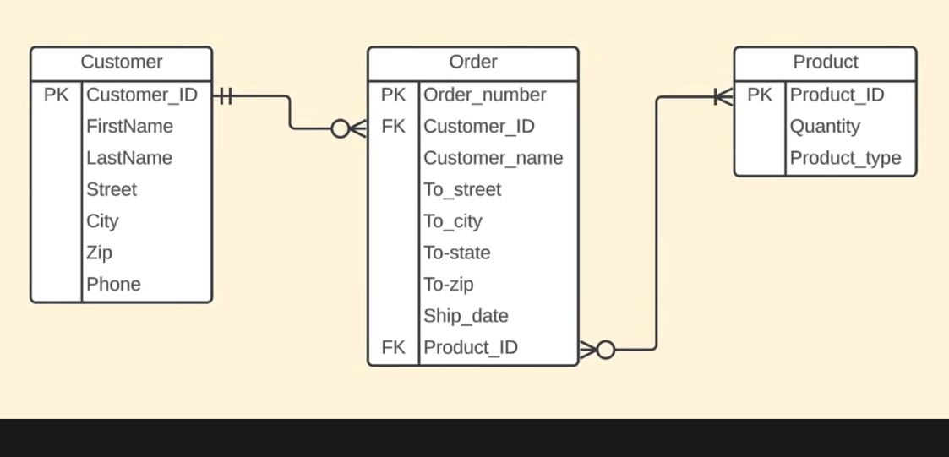

Data Flow Diagram (DFD)
Shows how data moves through a system: where it comes from, what transforms it, and where it rests. Only four symbols are used — external entities, processes, data stores and data flows — which keeps it accessible to non-technical stakeholders. It is decomposed in levels: a Level 0 context diagram of the whole system, then Level 1, Level 2 and so on for detail. Unlike a flowchart it has no decisions, loops or timing; it is about data movement, not control flow. Useful for integration work, privacy assessments and understanding legacy systems.
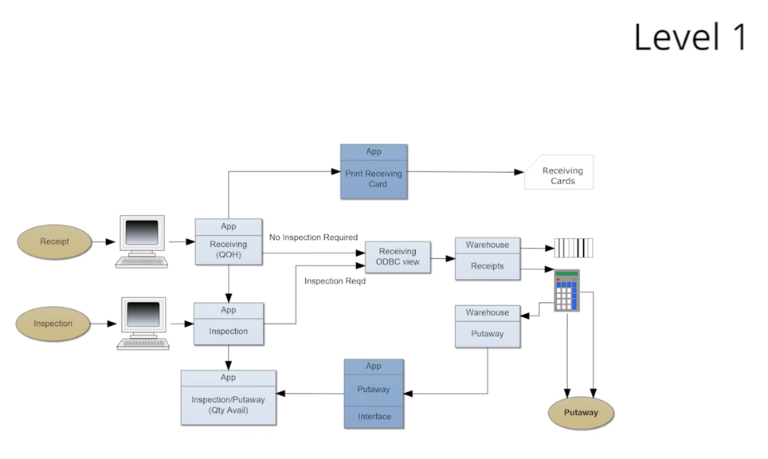

Wireframe / Mockup Diagram
A low-to-medium fidelity layout of a screen showing structure, content blocks and navigation without visual design. Wireframes are deliberately grey-box and unpolished so feedback focuses on function rather than colours and fonts; mockups add more visual realism. They make abstract requirements tangible, which surfaces misunderstandings far faster than written specs. Annotations usually accompany them to describe validation rules, states and behaviour on interaction. Use them for stakeholder sign-off and as input to UI development and test case design.
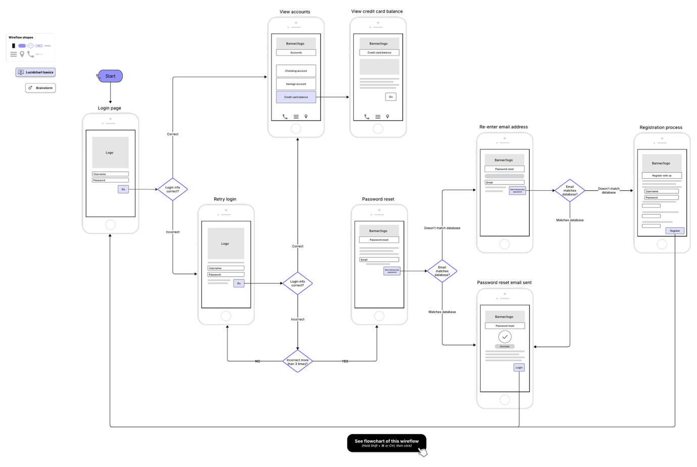

Swimlane Diagram (Cross-Functional Flowchart)
A process flowchart divided into horizontal or vertical lanes, one per role, team or system. Placing each step in its owner's lane makes accountability explicit and exposes every hand-off between parties. Hand-offs are where most delay, rework and dropped work occur, so this view is powerful for process improvement. It is simpler and less formal than BPMN, making it well suited to workshops and executive audiences. Common uses include onboarding, approvals, claims handling and any process crossing departmental boundaries.
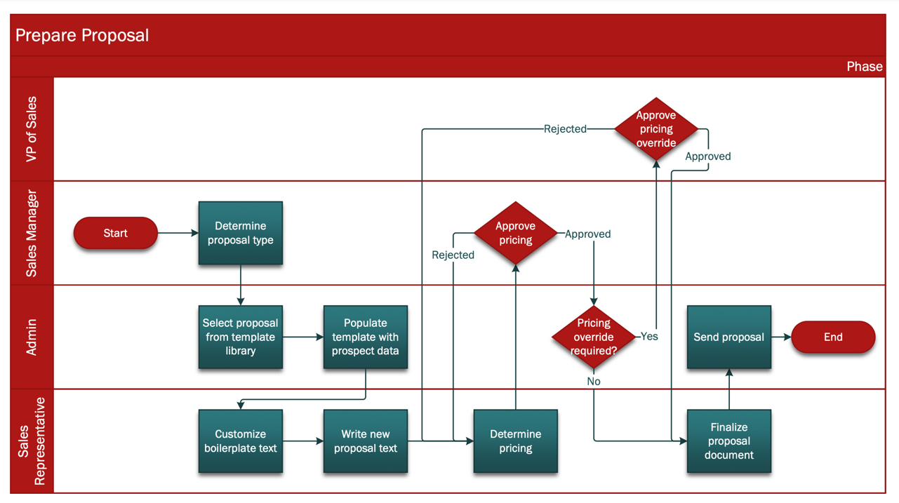

Gantt Chart
A horizontal bar chart plotting project tasks against a calendar timeline. Bar length shows duration, position shows start and finish, and arrows show dependencies between tasks. It highlights the critical path, milestones, overlaps and resource assignments in a single view. Progress can be shaded within bars to compare planned versus actual completion. Strong for predictive/waterfall delivery and reporting to sponsors; less suited to agile work where scope shifts each iteration.
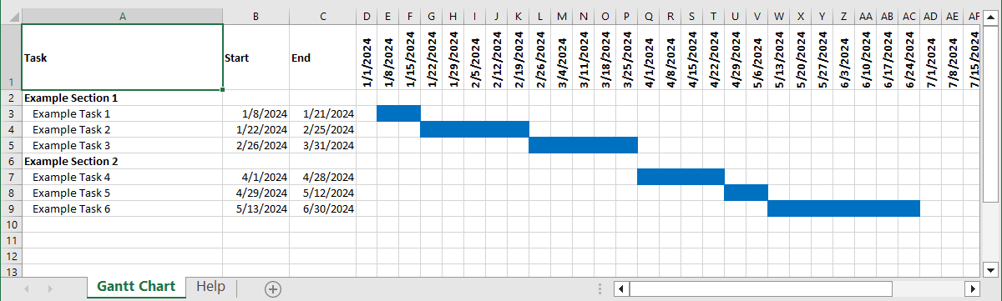

Stakeholder Map
A visual of everyone affected by or influencing an initiative, and how they relate to it. The most common form is a power/interest grid producing four groups: manage closely, keep satisfied, keep informed, and monitor. Other variants use concentric circles by proximity to the project or a network view showing influence between stakeholders. It drives the communication plan — who needs a workshop, who needs a monthly email, whose sign-off is mandatory. Revisit it during the project, since influence and attitudes shift as change becomes real.
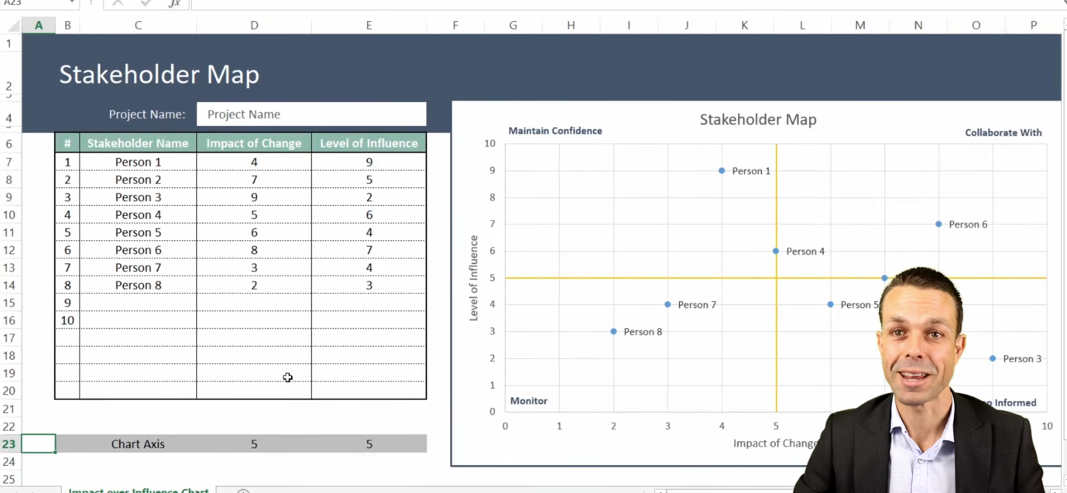

State Diagram
Models the lifecycle of a single object or entity as the set of states it can occupy. States are rounded boxes; transitions are arrows labelled with the triggering event, guard condition and any resulting action. It always has an initial state and usually one or more final states. Where a flowchart shows the order of activities, this shows the condition something is in and what legally moves it. Ideal for things with a status field — an order, a claim, a ticket, an account — and excellent for deriving test cases and spotting invalid transitions.
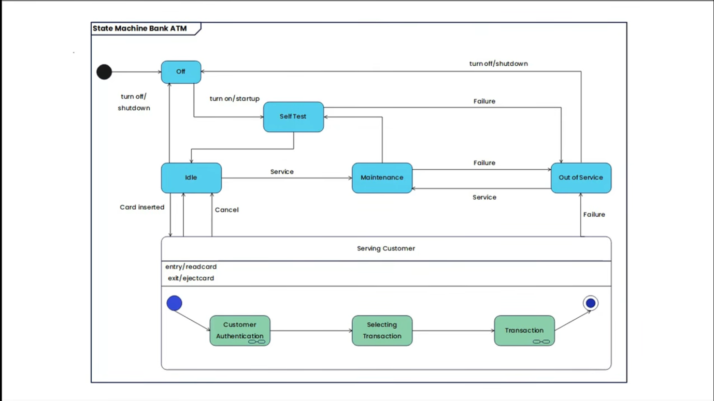

Requirement Traceability Matrix (RTM)
A table linking each requirement forward and backward through the delivery lifecycle. A typical row carries a requirement ID, description, source or business need, design element, build item and test case. Forward traceability proves every requirement is built and tested; backward traceability proves nothing was built that nobody asked for. It makes impact analysis fast — change one requirement and you can see everything downstream that is affected. Heavily used in regulated environments such as finance, healthcare and defence where evidence of coverage is auditable.
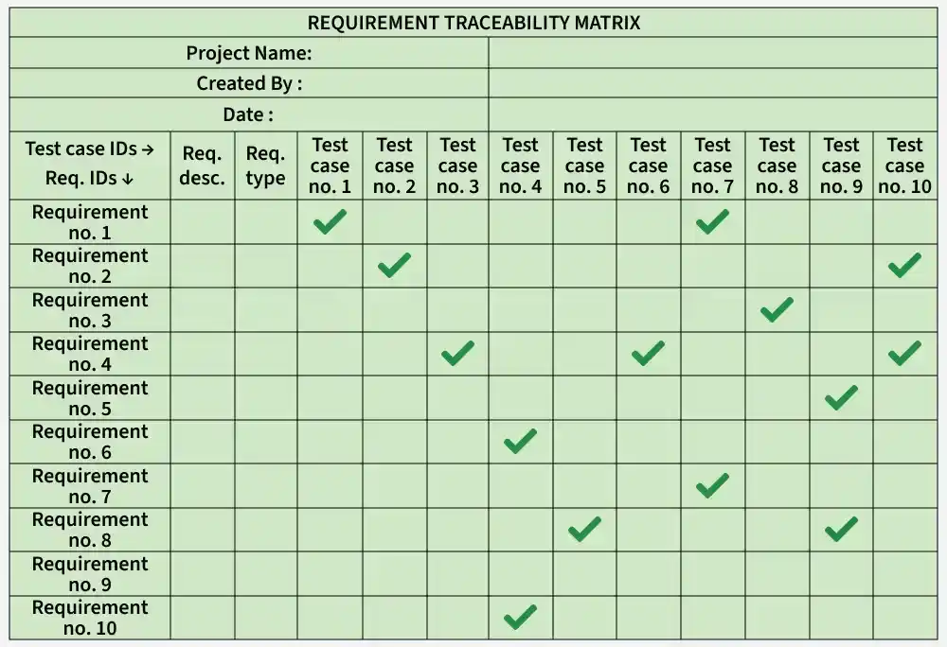

Gap Analysis Diagram
Compares the current state ("as-is") against the desired state ("to-be") and makes the difference visible. The gap itself is the space between the two, and each gap becomes a candidate initiative, requirement or change. Presentation styles vary: side-by-side columns, a two-row table with a gap column, or a bridge/staircase showing the steps that close the distance. Gaps can be assessed across people, process, technology and data rather than technology alone. It justifies the business case by tying every proposed change to a specific shortfall.
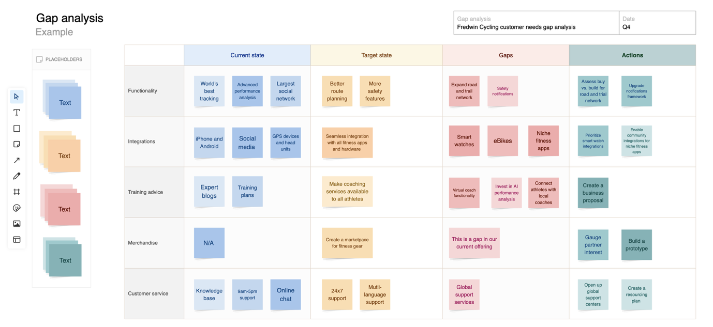

Activity Diagram
A UML diagram showing the flow of control through a set of actions, including branching and parallelism. Notation includes a start node, action boxes, decision diamonds, fork and join bars for concurrent work, and an end node. Fork/join is its key advantage over a plain flowchart — it can express work happening simultaneously. Partitions (swimlanes) can be added to show who performs each action. Best used to detail the internal logic of a single use case or a complex algorithm, sitting one level below the use case diagram.
